We have successfully build Finance App , Accommodation Control System with Python ,Flask ,Node ,Next JS , Postgres etc…

Now We need to build powerful Legal Case Control System for Our company with full professional style , below I will explain each requirements .

Small Description : -

We have a multi Branch group of companies and working centralized accounts via head office , each division have managers , accounts team ,Sales manager like all employee structure .
Head office Have Audit team , Finance managers for retail and distribution Separate person and legal department .

Simple flow explanation ;
Login Division Accounts fill the legal case application form attached supporting docs then submit then print the application form > login Division manager ,review the application Approve >after physical docs send to head office same time Accountant update status send to Head office > Head office audit department receive the physical application form then change status to Application received > then audit team verify the application form cross check with real account software then commend and handover to Finance manager same time Auditor update Handover to FM with commands ,Finance manager review the form and need option if any correction then ask to division accounts for clarification and update the status then forward to Executive Director same time update status with command . once ED review and signed the physical form then ED or FM update the status with command and take final Approval From Chairman or MD .> after FM Send to Legal department with status and command . Then Legal person review the docs and fill the case govt system ,once filled lawyer have option for update command with attachment like Govt Acknowledgement with case number Filled Date (there need two number filed one Police number and Court case number …
Then above is up to filling after this layer or FM have option for update each case hiring commands ,next hiring date .status like rejected ,fund received ,closed ,pending ,Signatury out of country etc….. all useful status update with attachment .

The flow I have explain above ,below I will provide the sample structure and requitements.
Legal Entry Form
Currently using form here attached .
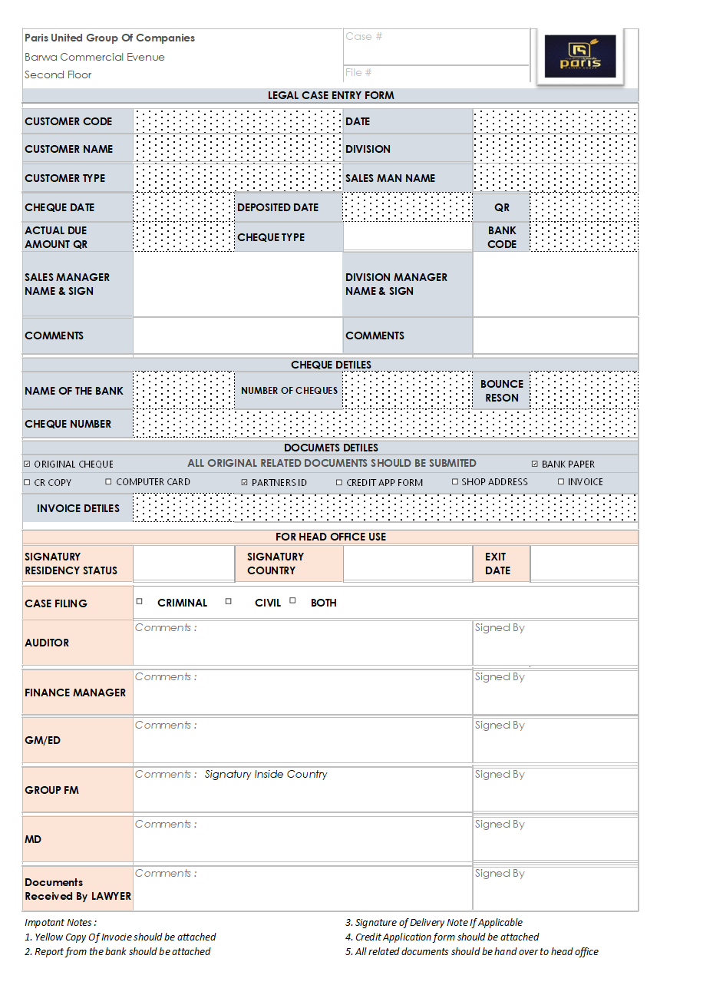

Customer name input Drop down Selection from Master Customer Creation .
Date Auto filled today date
Customer type , sales man name Drop down Selection from Master
Actual Due Amount
Legal filling mount
Deposit Date
Bank Code form Master input Dropdown
Commands

Cheque Detail
Cheque Number ,Bank name or code ,Amount , type of cheque like Guarantee or Normal,bounce reason etc..
And option for add multiple cheques with +button .
Attached Documents cheque box with attachment .
Case filling Chek Box ,Criminal , Civil ,Both ,

Below the signing filed
Accountant > Sales Manager > Division Manager > Auditor > FM > ED > Chairman or MD >Layer .
On the form have option for Select Manager ,Sales manager ,FM etc… Accountant auto select from longlined user

Save And Print .
Form header should be Company branded with Paris united group Holding Logo .
It should be standard and cute print style for a professional corporate style .

Here below I will attached sample SOP for Your reference .

All Samples attached on folder name called files on the created repo .

Each Menu Sub Menu as per my idea , you can do it as a professional style
MASTER
- Division Creation > Code Auto > Division name > Address > Accountant email > Manager Email > Sales Manager Email etc…
- Bank Creation Bank Code > Bank Name
- Sales Man Creation Code Auto > Name > Email >linked Division
- Manager Creation ,Accountant Creation ,Sales Manager ,FM ,ED,MD Auditor like all creation master .this for linking and user role assignment .
- Customer creation > code >Name > linked division >Sales manager like etc…
- And if any other creation needed .
TRANSACTION TAB
- Create new case (above form )
- Status Update ,Status update visible against User role and flow ,
- Case updating
- Layer Status updating case filled with attached , Civil Case done , and option for attach all docs on every case hiring documents . next hiring date and time ,location etc…
- Like all related with useful Transaction entries ,
- Case related Expenses request by layer and entry record on the selected case . for we should know from our system how much total spend
- Lawer have option for request cash > then FM receive notification or email ,> once FM Approved then go to Divison accountant screen , issue cash > received by legal full status update .attach receipt of the payment by Accountant /FM /Layer
REPORTS .
- All professional level report , and case flow chart step by step . Rejeted filter , payment received ,closed ,pending , hold like all legal case related
- Detailed case report , it should have option for view and print all attached docs ,case flow chart etc…..
- Management level case status report like summary and current position .
USERS AND ROLE
- It should have role based user Permission like Accountant ,FM ,ED ,Audit ,Layer ,MD ,Chairman etc..
- User Creation > Create User by Admin or Super User , link with Divison Multiple or Single .exmaple IF Auditor /Fm/ layer creation some time they Should access multiple division case data . if accountant he can access only that division related reports only
Notification
- Each step should have notification via email (branded Email ) and dashboard .email deliver as per rule based .
MAIN DASHBAORD
- Advanced Level Dash With all use full date , like next hiring date , Recent updated ,total case filled ,rejected , closed ,Under prison etc…. total legal proceed amount with division name .advanced level chart and analysis dashboard .
Settings
Email Configuration , Ai Configuration , Full Settings ,light mode ,dark mode ( home page also have light /dark mode switch .

Tools All advanced System : Python ,Fast Api ,redis ,postgress ,node js ,react,typescripts , Tailwind CSS ORM: SQLAlchemy. Custom PDF/Excel generation, JWT,etc….

Here I have provided data’s are my small knowledge , review the complete I have privded above and research the professional system with advanced level legal case Control System then provide full structure with Phase to Phase Development steps .
Phase should be setup against Claude Code token usage for avoid 5 hour limit interruption .
And save the phase plan as a html format on repo docs folder and once I inputs start Phase 0 then only start coding

